

**Database Diagram**

**Information Technology Project (IT2080)**

**2019**



**August 8, 2019**

**ITP-2019-MLB-G9-08**

|  |  |
| --- | --- |
|  | Name |
| IT18050868 | Z.M.M. Akaam |
| IT18152074 | Sangeeth Raj .A |
| IT18144772 | Krishnamoorthy.N |
| IT18108132 | Edirisinghe E.N.V |
| IT18118650 | Jayasooriya D.C. |
| IT18044928 | J.L Thilini Randika |
| IT18128932 | Devduni.R.M.B |
| IT18118414 | Imalsha Kavindi K.G. |

**ER DIAGRAM**

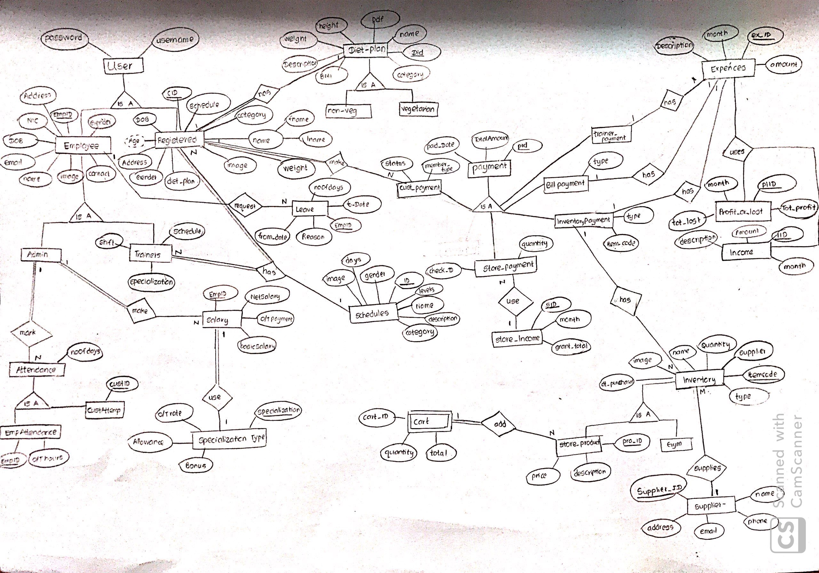

**DATABASE DIAGRAM**

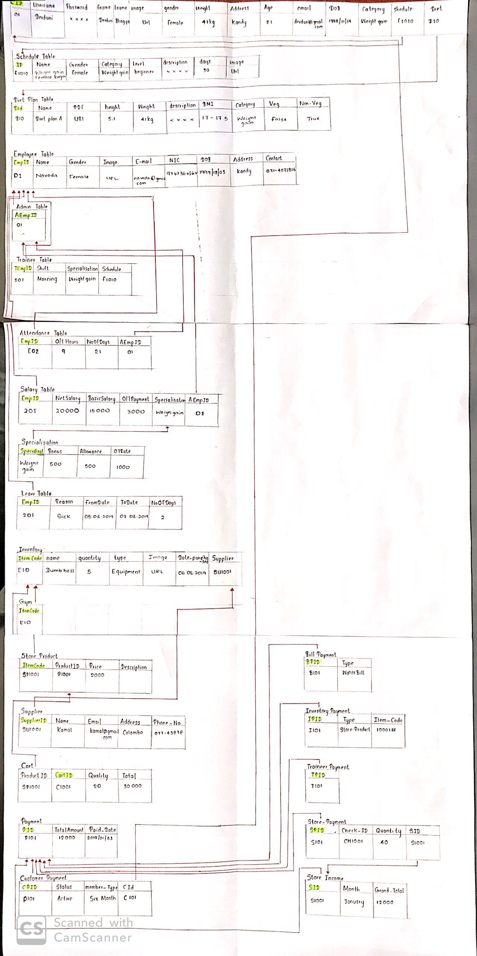

**RELATIONAL SCHEMA**

